Python Assignment 3: While Loop, For loop and Function

Number Guessing Game

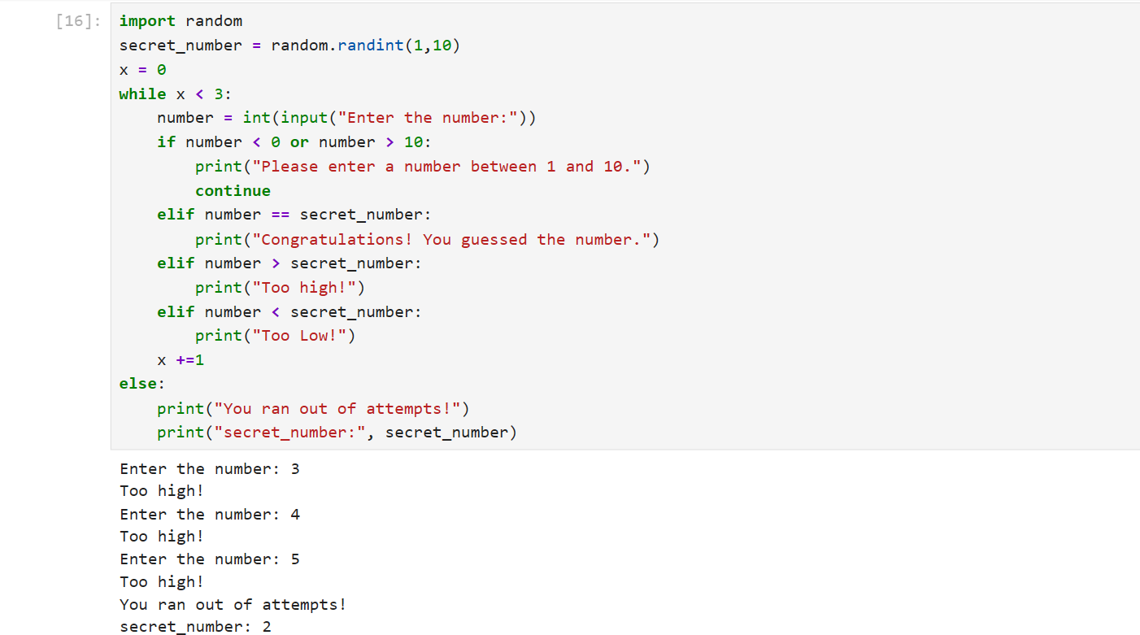

For Loop:
Multiplication Table Generator

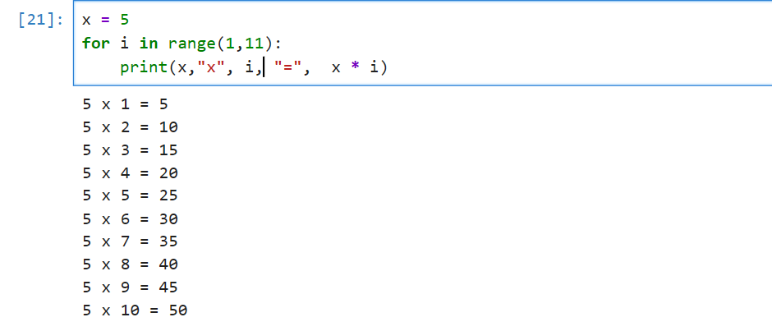
Function:
BMI Calculator
